FORMATING INSTRUCTIONS
A TEMPLATE FOR
THE 15TH INTERNATIONAL
CANDU FUEL CONFERENCE SUBMISSIONS

A. Author1¹, B. Author 2² and C. Author3¹
¹Cameco Fuel Manufacturing, Port Hope, Ontario, Canada
(Address, Phone, Email of corresponding author)
²Bruce Power, 123 Front Street W, Toronto, Ontario, M5J 2M2, Canada

Abstract – The abstract is to be no more than 100 words. The required full paper is to be submitted in Microsoft Word. CANDU Fuel Conference papers should be submitted on-line to the CNS at the link below:
https://www.xcdsystem.com/cns/abstract/index.cfm?ID=b9v4aBI

1. Introduction
This document provides the template for authors to format their papers to a common standard used for the CANDU Fuel Conference.
To ensure a uniform presentation and standard of content in the papers submitted to the CANDU Fuel Conference, the page limit of full papers is 12 letter-size (8.5”x11”) pages including tables, figures and references. The page limit will help the authors to concentrate their discussions, reasoning and materials.
The text margins are to be set so that the text body is within the dimensions of 1-inch margins bottom, left and right, and 1.2-inch top margin.

2. Body text formatting
The body text of the paper contains headings, subheadings, pictures, diagrams, tables, figures, formulae and other relevant information. Section headings should be in bolded 12 point Times New Roman font. A number and a dot should be inserted for each heading, in increasing order to the end of the paper. The first letter of the heading should be upper case and the rest of the heading is lower case unless the word requires upper case (e.g., CANDU, Ontario Power Generation). Include a tab space of 0.5 inch from the left margin to the heading itself. Leave 2 blank lines (24 pt space) between the last paragraph and the heading title line – this template has been adjusted so that the paragraph and heading spacing is correct. Paragraphs in the body text are separated by one blank line (a 12 pt space at the end of the paragraph is used in this template). You are encouraged to use page breaks to force heading titles to appear on the same page as the text of that section.

Body text should be in Default 12 point Times New Roman font. If you want to emphasise certain words in the text, you can highlight those words by using bolded, italicized, or underlined font, or by changing the font type and size, provided these changes are confined to drawing the attention of the readers. The overall paper must be in normal 12 point Times New Roman font.
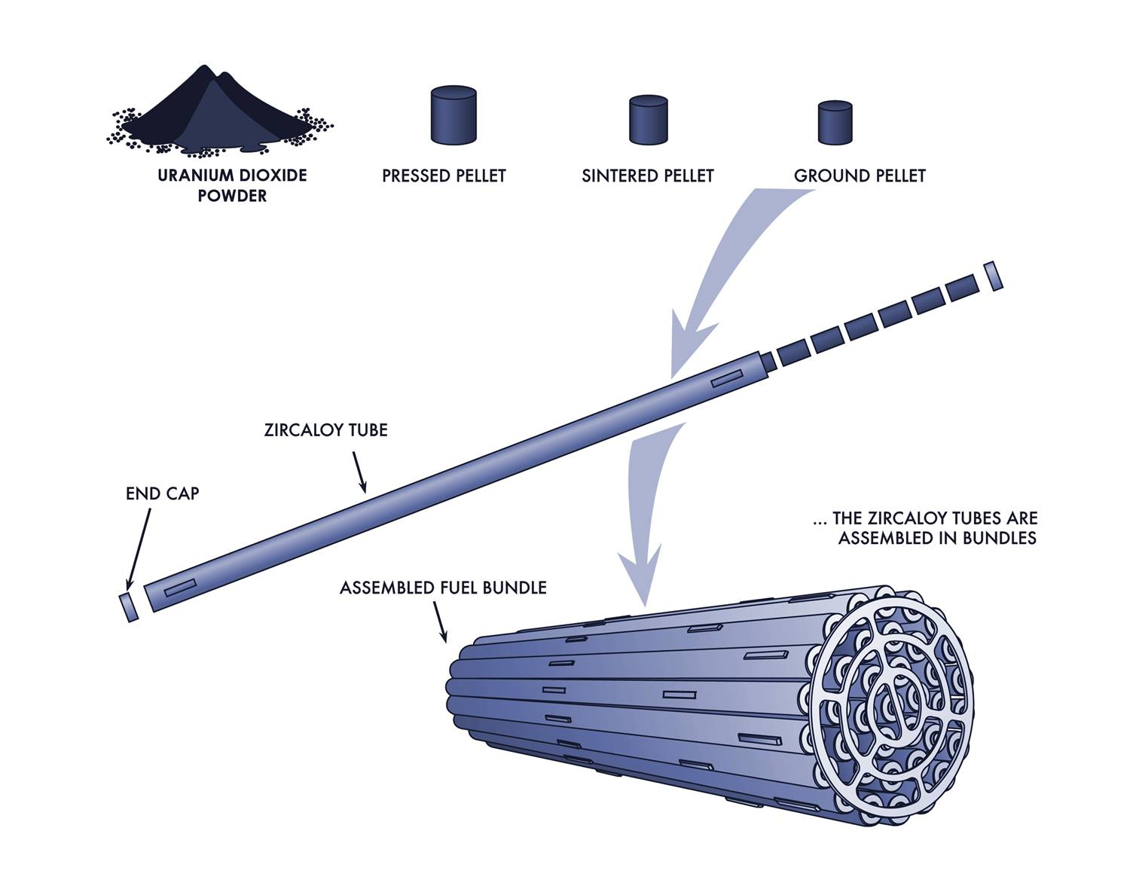
Figures (diagrams and photographs) and tables can be included anywhere in the text other than the title, author list or affiliation list. Figures should be numbered consecutively throughout the paper from Figure 1 onwards. Tables should be numbered consecutively throughout the paper from Table 1 onwards. All figures, tables and their captions are to be centred. Ensure figures and tables are within the printable area of the page. The conversion of your Microsoft Word file to a pdf file (performed by the CANDU Fuel organizing committee) can result in omission of images if they are not within the printable area of the page.

Figure 1 Example of a Figure.

There is no restriction on the size of a diagram but, as a general rule, a diagram should not extend beyond the margin of the letter paper in any direction. Leave one line between the body text, the diagram and the caption.

Table 1 Title of Table

Header | Header | Header
xxxxxxxxx | 111 | 11
yyyyyyy | 22 | 2222
zzzzzzzzzzz | 333 | 333

In all respects, pictures are inserted in the same way as diagrams. All pictures and diagrams are to be inserted in line with text. Ensure the figure image cannot appear on a separate page from the caption.
2.1 Subheading in a heading section
Subheadings are recommended to provide clarity of ideas. The subheading should be in bolded 12 point Times New Roman font. The first letter of the subheading should be in upper case and the remaining words should be lower case unless the word requires upper case. Subheadings are numbered with a period separating the section number and the subheading number (e.g., 2.1 and 2.2 are subheadings in section 2). The subheading title is separated from the subheading number by a tab space 1 cm from the left margin. The body of text in the subheading section is aligned and formatted identical to other sections. A single line is used to separate a subheaded section from other subheaded sections and other text in the same heading section.
2.1.1 Sub-subheading in a subheaded section
In case a sub-subheading is required, the same principles apply. The sub-subheading title is to be in underlined (i.e., non-bolded) 12 point Times New Roman font.
3. References
References in the text can be made to literature listed in the reference section, located at the end of the paper, by numbering the literature with numbers in square brackets e.g., [1]. The references are incremented in sequence of appearance in the text. Repeated references to the same literature can be made using the same reference number [1]. In this case, the reference number will be incremented on the next new literature cited.
The format for references should be: name of authors (family name then initials of all other names, authors are separated by commas), “Title of paper within quote marks with the first letter upper case and the rest lower case unless the word requires upper case”, Journal name in italics, Vol. number, Issue number, year and pages [1]. In the case of conference proceedings, underline the conference name.
For formulae, equations are numbered in their order of appearance in round brackets and are referred in the text if necessary.
E₁ + E₂ + …..+E_{k} = (m₁ + m_{2+.…..+}m_{k} ) c² (1)

4. Conclusions
We have developed a format for the full papers submitted to the 2022 CANDU Fuel Conference. We hope that the authors find this template useful and the guide easy to use. If there are any problems or questions regarding this template, please contact the CANDU Fuel Conference Technical Program

Chair Dr. Paul Chan by email Paul.Chan@rmc.ca. We wish you every success in the preparation of your full paper.

5. References
[1] F. M. LAST, The Title of the Book, page or chapter numbers, Publisher, City (year).
[2] F. M. LAST and J. S. Smith, “The Title of the Journal,” Journal Name, volume number, issue numbers, page number (year).
[3] F. M. LAST and J. S. Smith, “The Title of the Paper,” Proc. of the Title of the Proceedings, Journal Name, Vol. , p. , Publisher, City, Country (year).

Acknowledgement

Nomenclatures

